**RAMANUJAN COLLEGE, DELHI UNIVERSITY**

**PRACTICALS**

**OPERATING SYSTEM**

**Submitted By: Om Krishna Gupta**

**Submitted To: Mrs.Sheetal Singh**

**Rollno:20221471**

**Semester – III**

**Course-BSc (Hons) Computer Science**

1. Execute various LINUX commands for:

i. Information Maintenance: wc, clear, cal, who, date, pwd

ii. File Management: cat, cp, rm, mv, cmp, comm, diff, find, grep, awk

iii. Directory Management: cd, mkdir, rmdir, ls

OUTPUT:

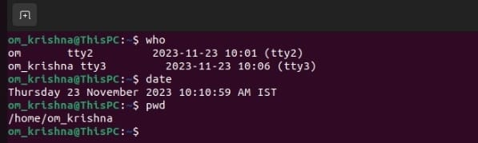

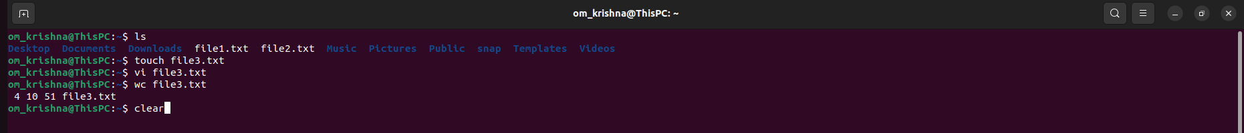

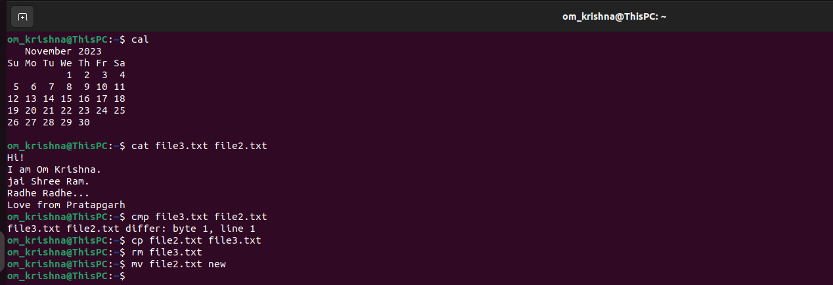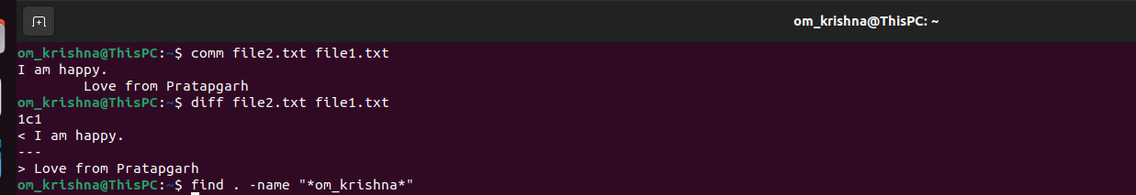

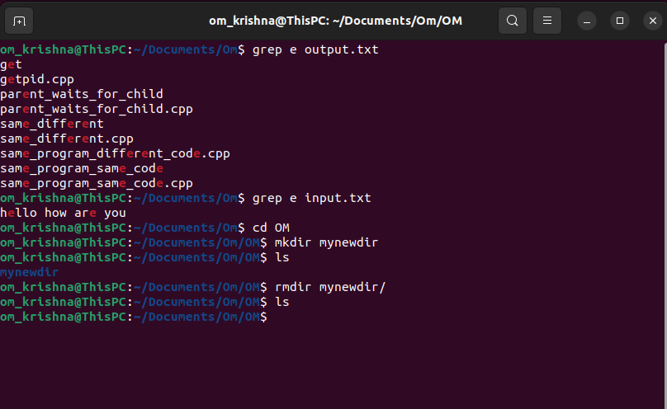

2. Execute various LINUX commands for:

i. Process Control: fork, getpid, ps, kill, sleep

ii. Communication: Input-output redirection, Pipe

ii. Protection Management: chmod, chown, chgrp

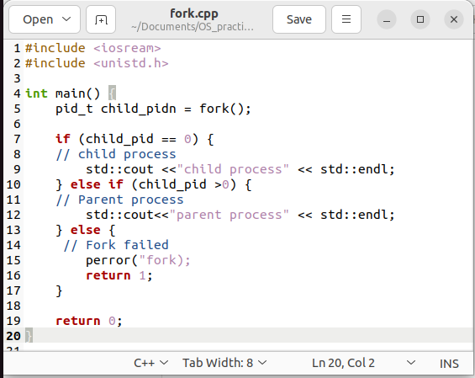

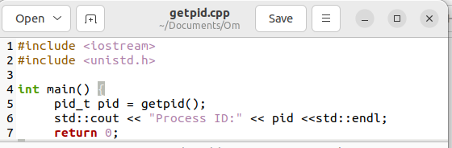

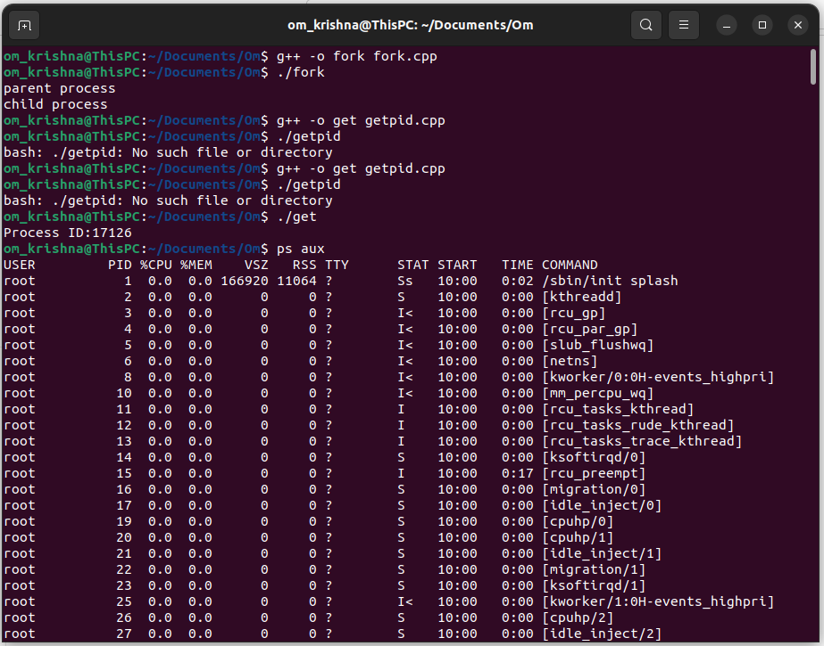

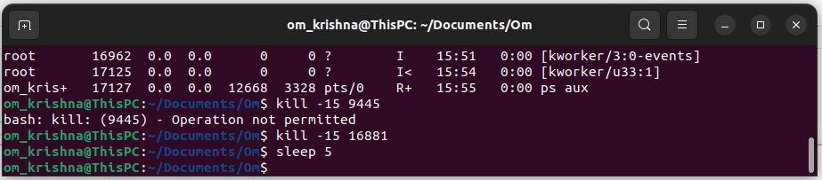



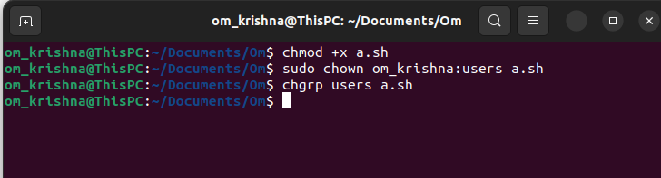

3. Write a program (using fork () and/or exec () commands) where parent and child execute:

i. same program, same code.

ii. same program, different code.

iii. before terminating, the parent waits for the child to finish its task.

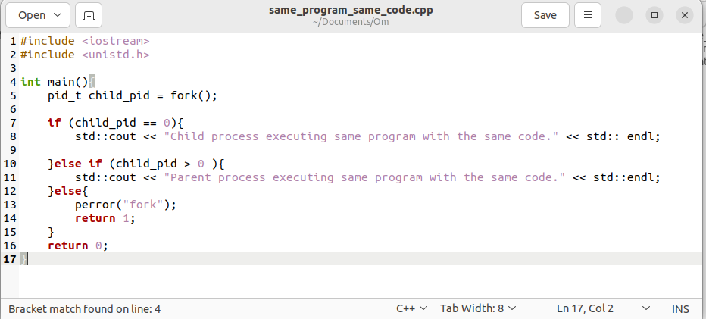

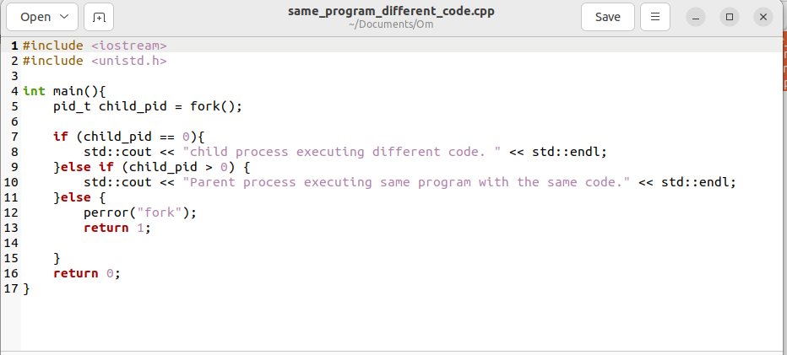

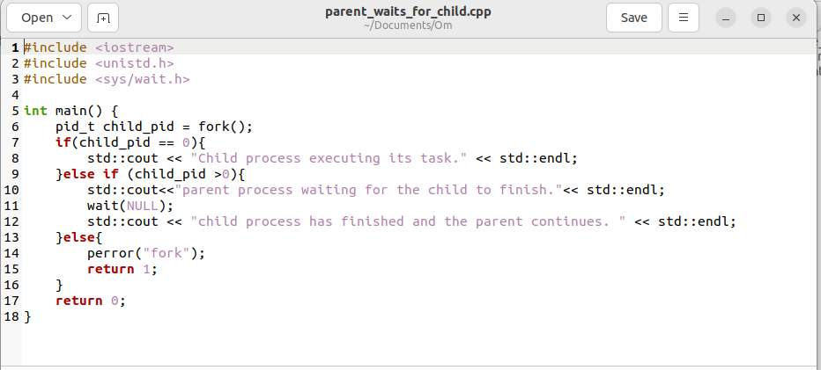

OUTPUT:

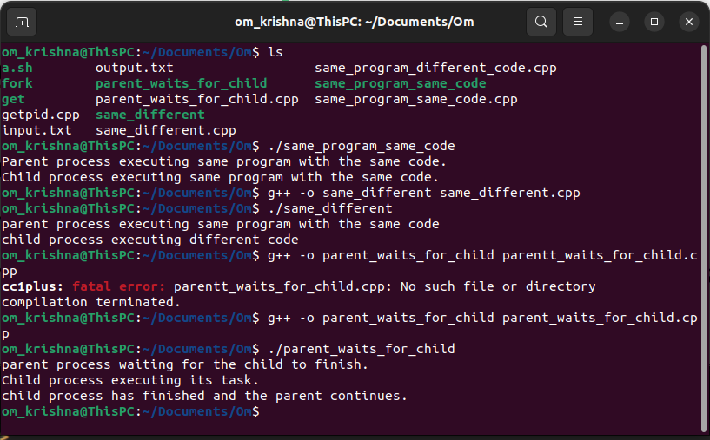

4. Write a program to report behaviour of Linux kernel including kernel version, CPU type and CPU information.

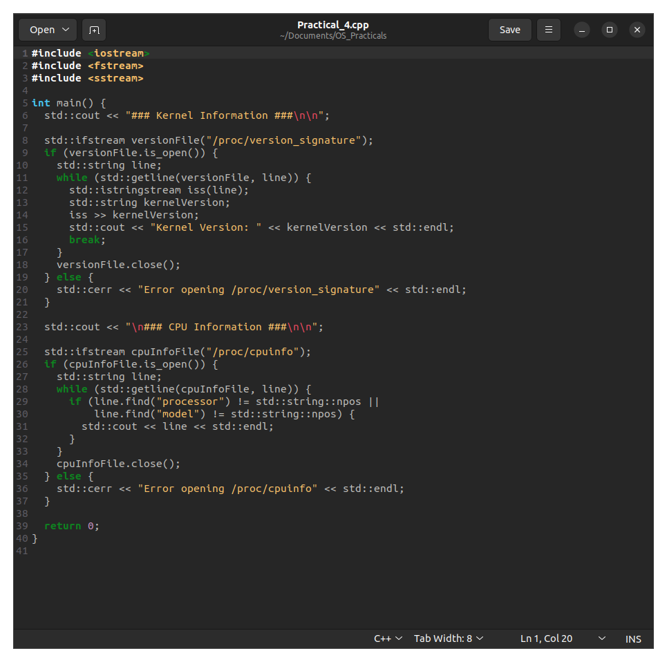

OUTPUT:

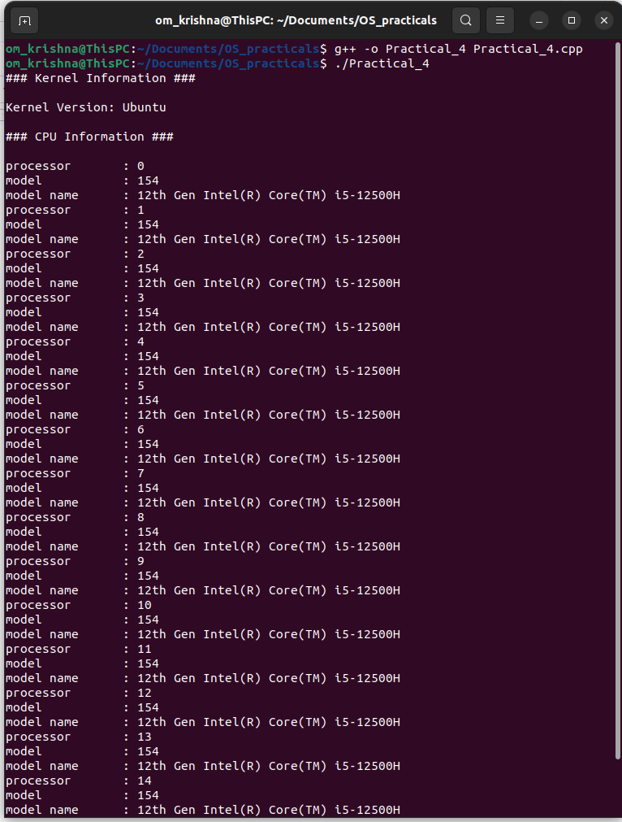

5. Write a program to report behavior of Linux kernel including information on configured memory, amount of free and used memory. (Memory information)

OUTPUT:

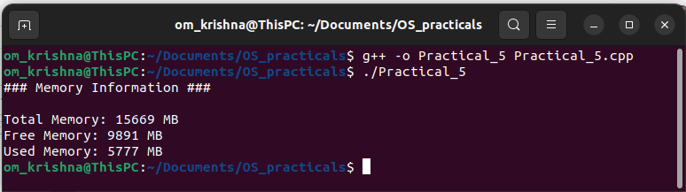

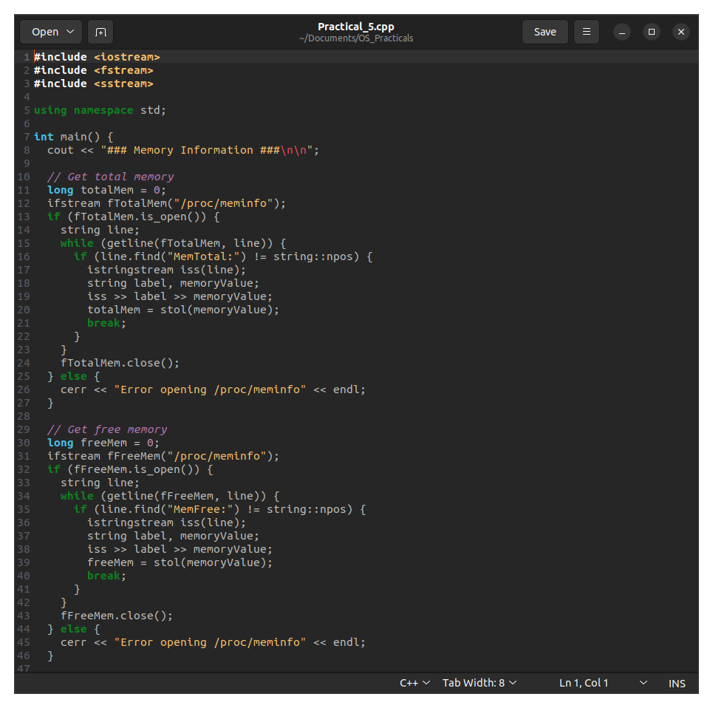

6. Write a program to copy files using system calls.

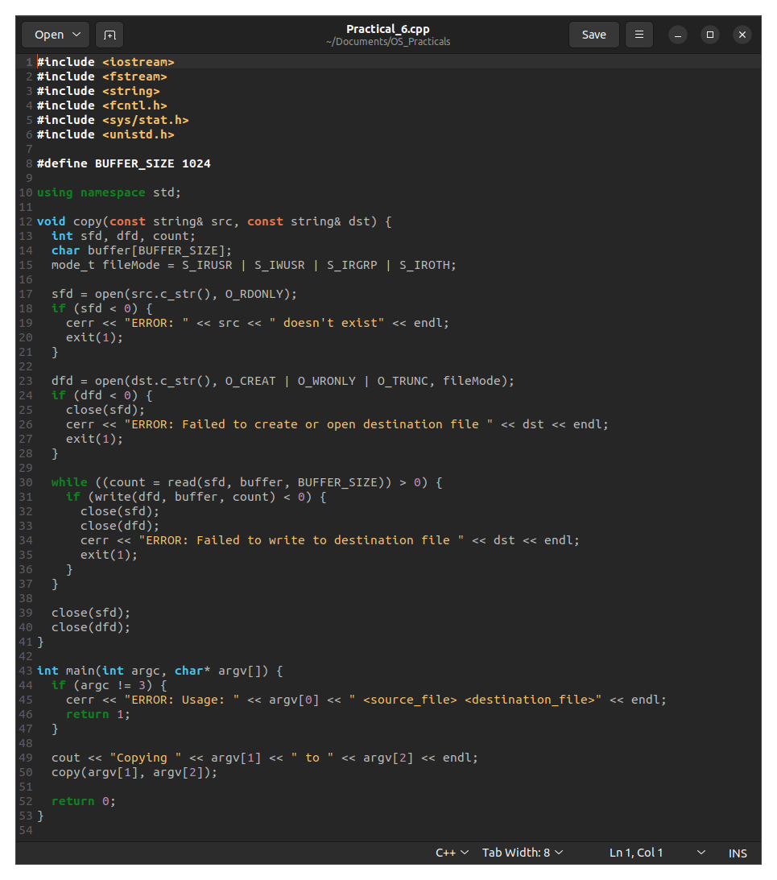

OUTPUT:

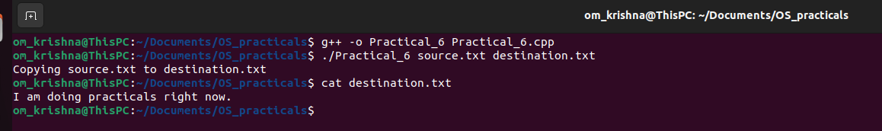

7. Write a program to im plement FCFS scheduling algorithm.

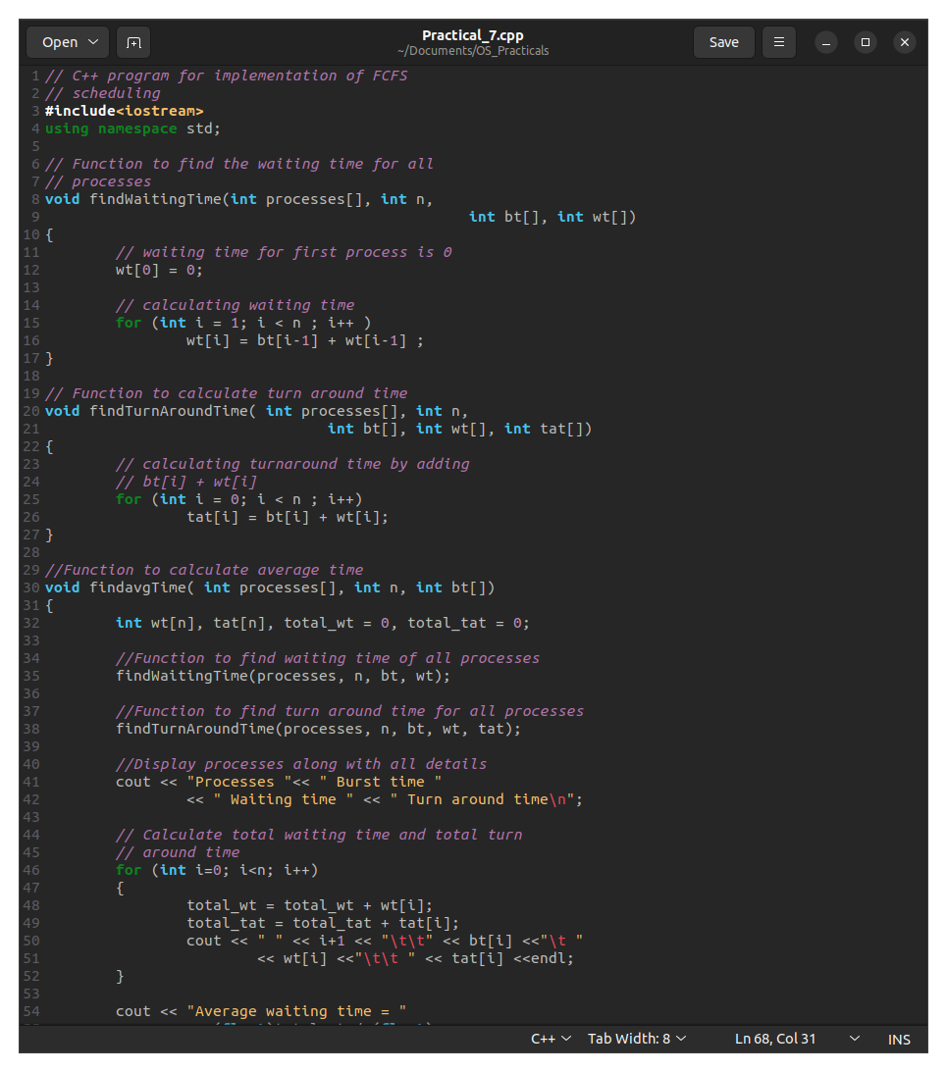

OUTPUT:

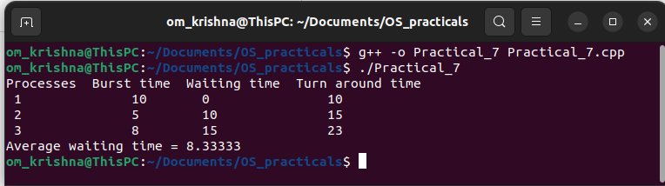

8. Write a program to implement SJF scheduling algorithm.

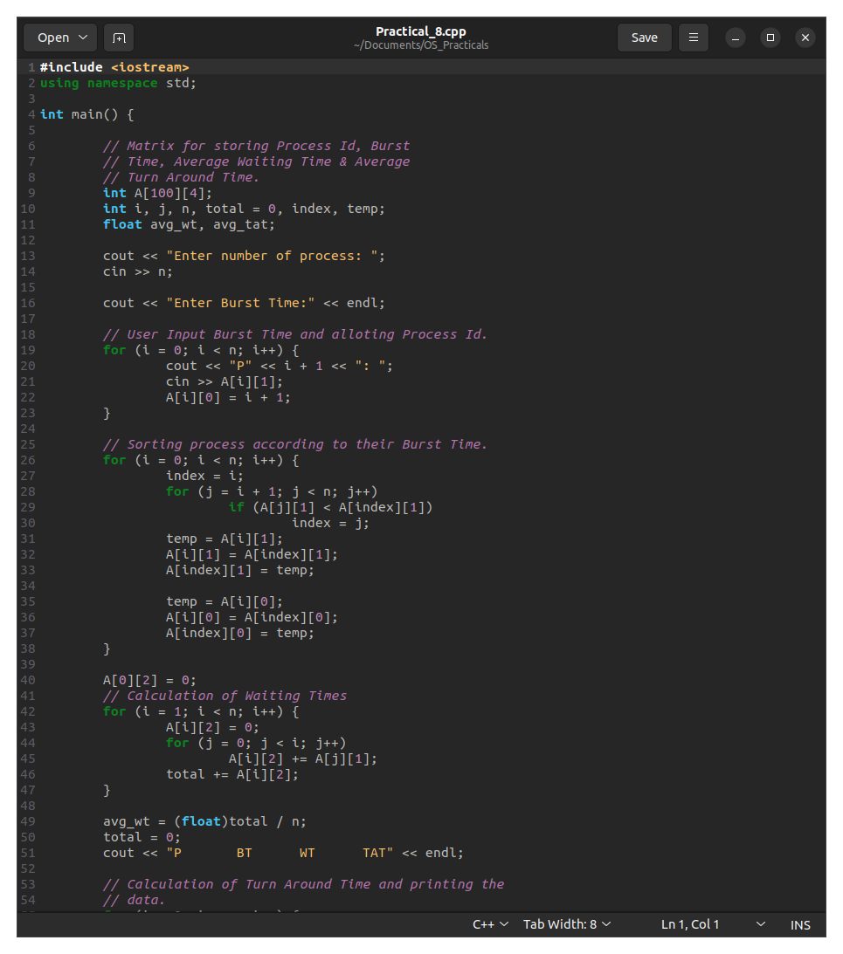

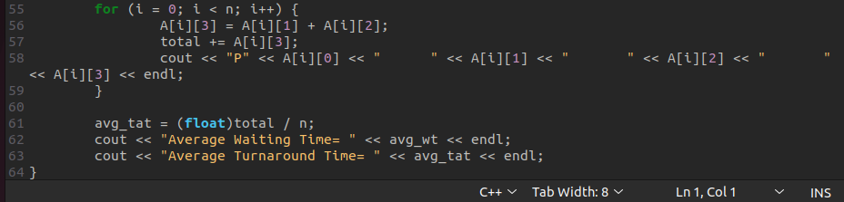

OUTPUT:

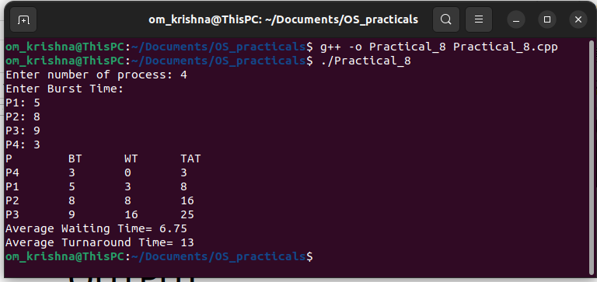

9. Write a program to implement non-preemptive priority-based scheduling algorithm.

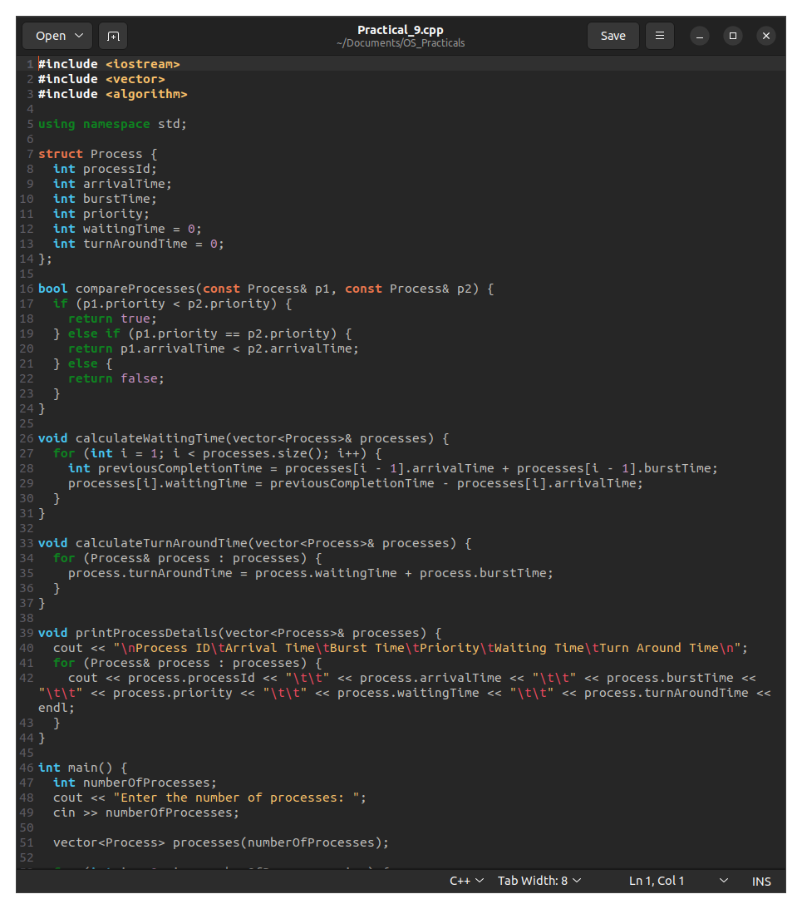

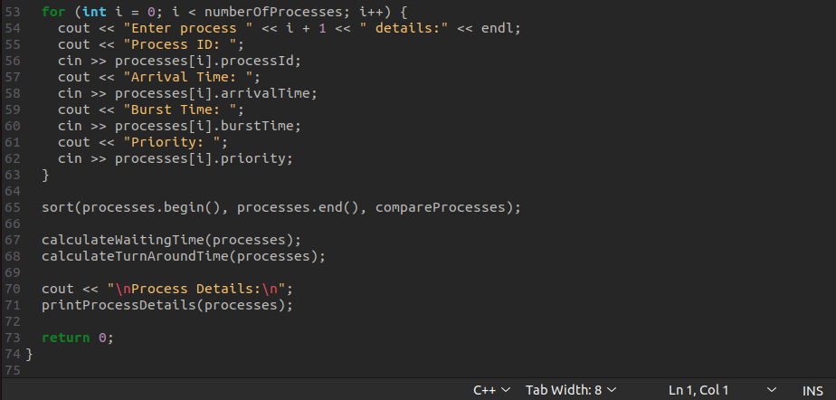

OUTPUT:

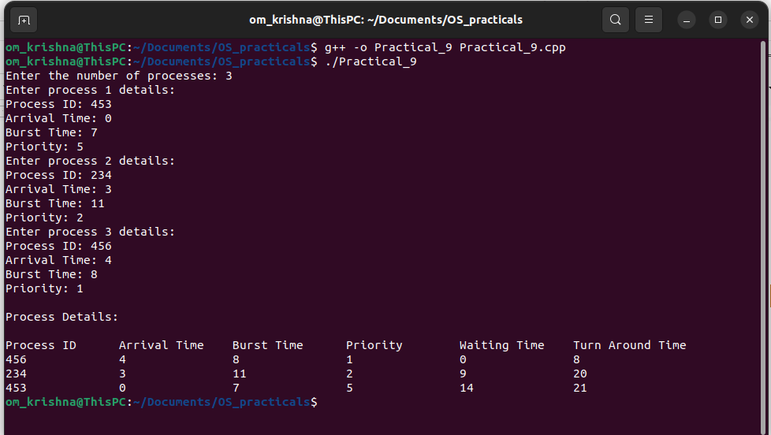

10. Write a program to implement SRTF scheduling algorithm.

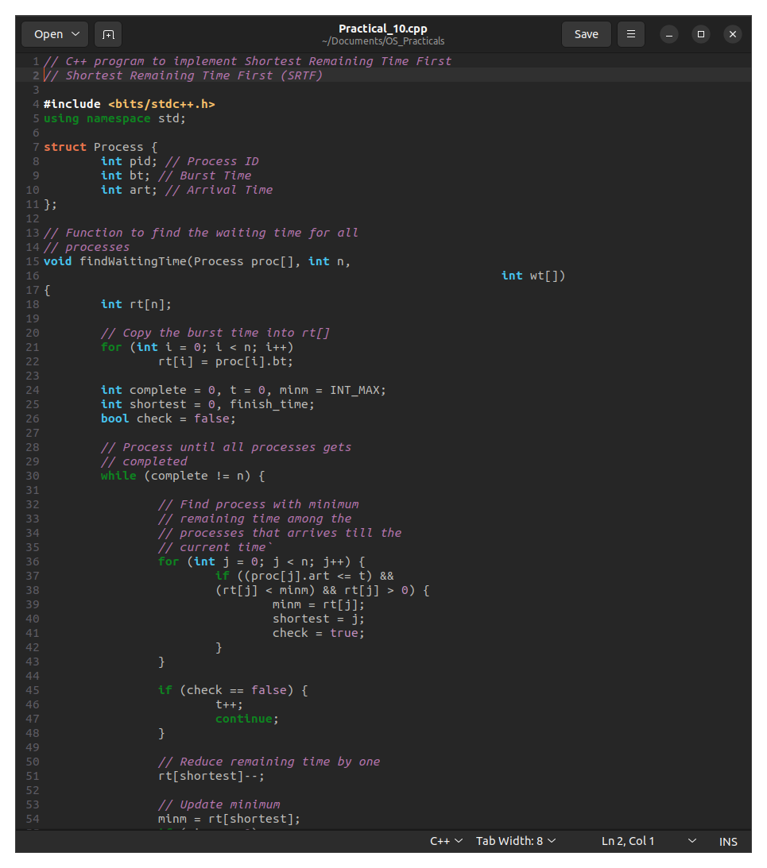

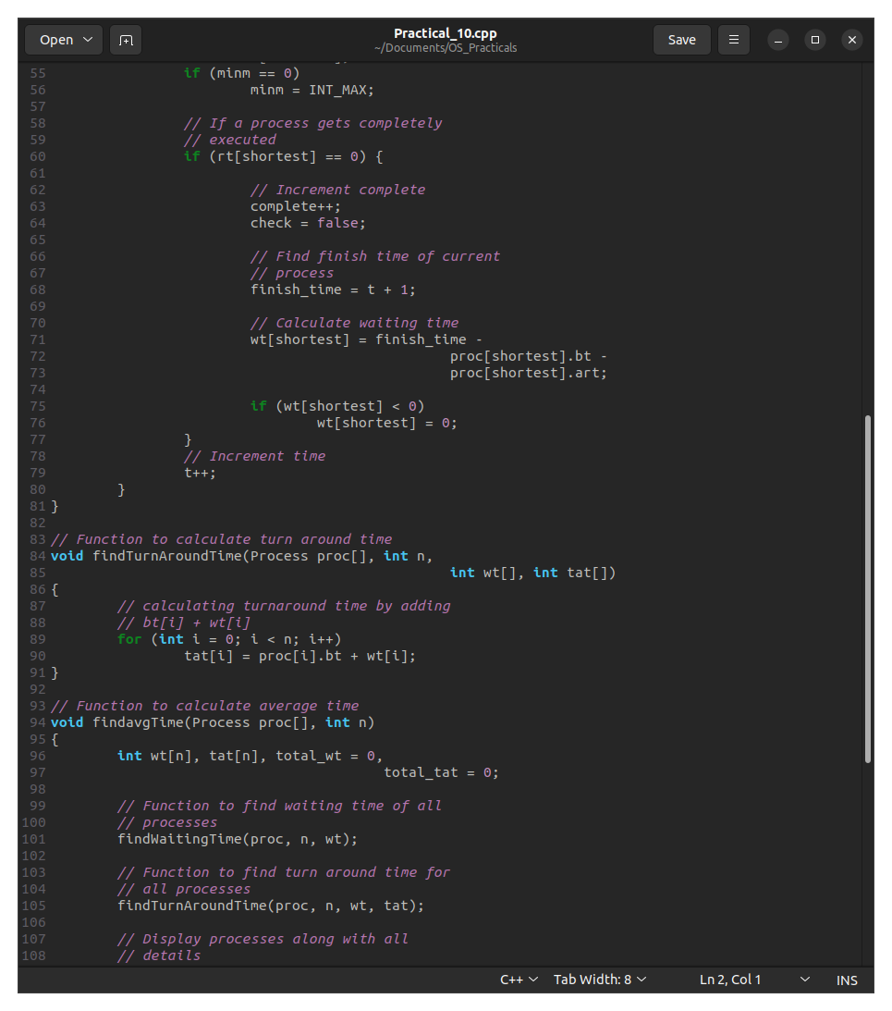

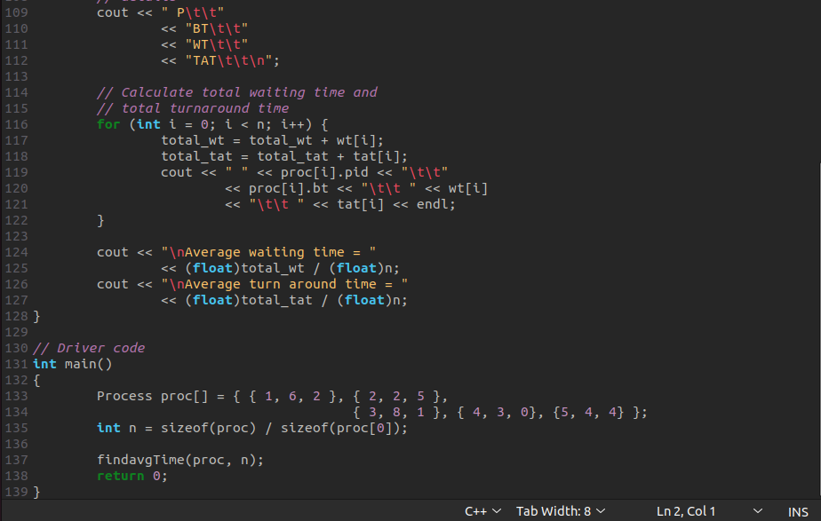

OUTPUT:

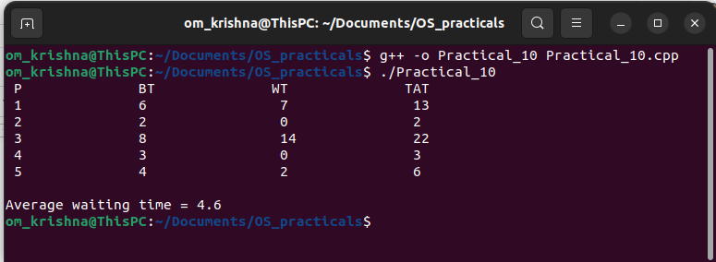

11. Write a program to calculate sum of n numbers using Pthreads. A list of n numbers is divided into two smaller lists of equal size, two separate threads are used to sum sub the lists.

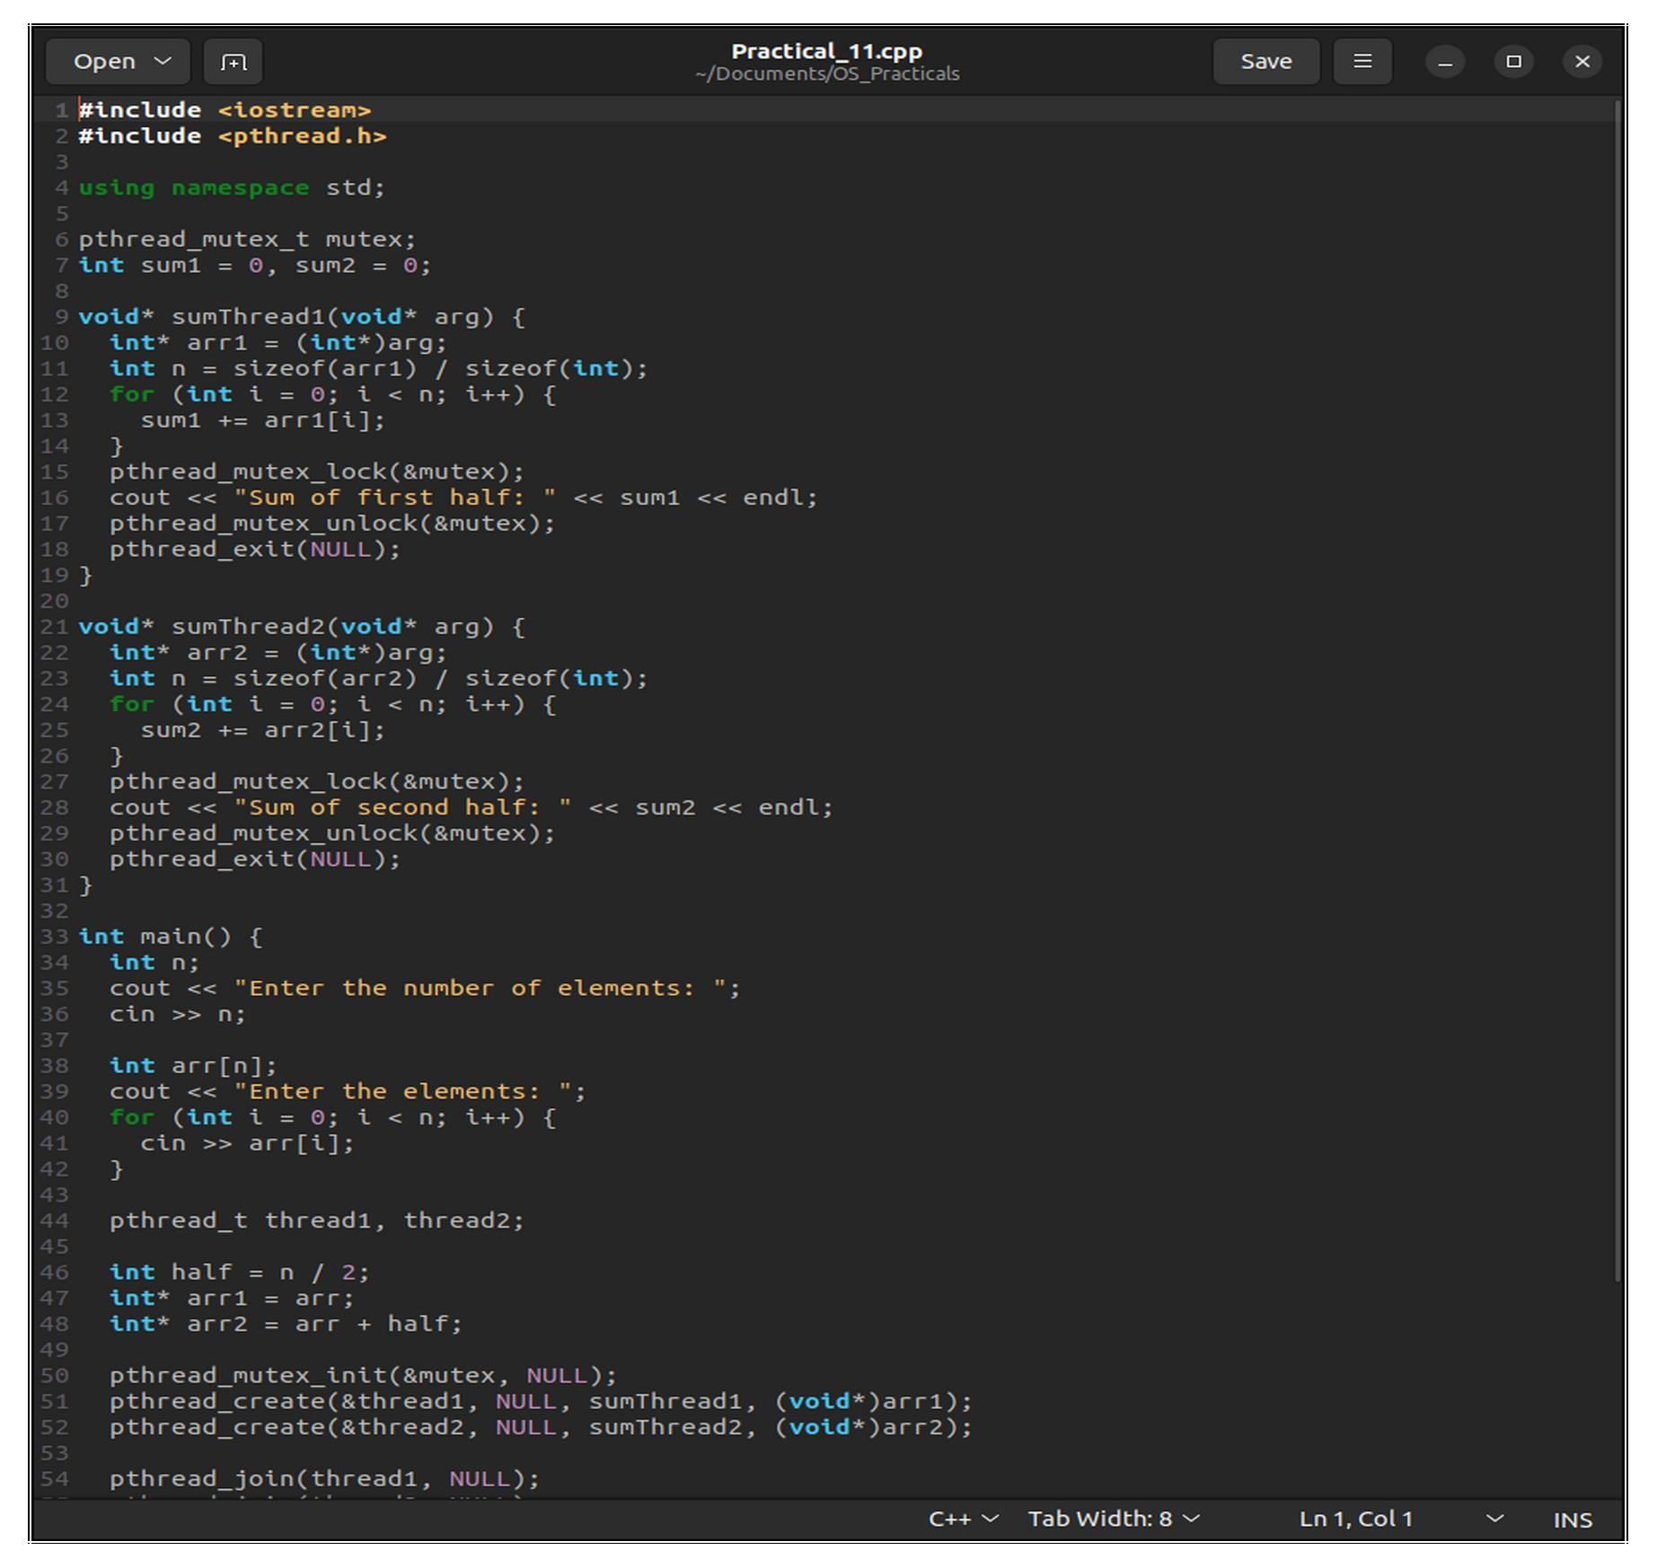

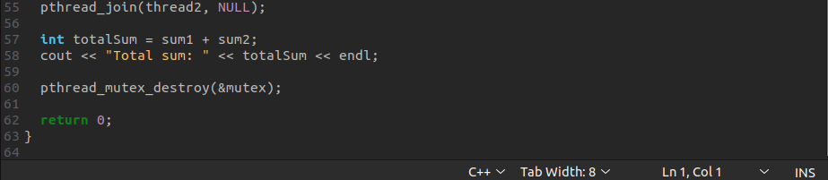OUTPUT:

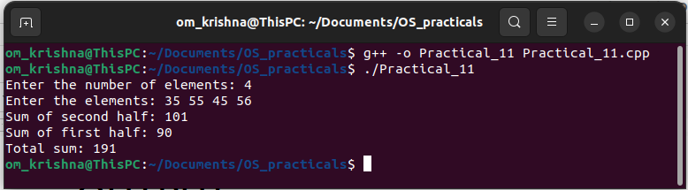

12. Write a program to implement first-fit, best-fit and worst-fit allocation strategies

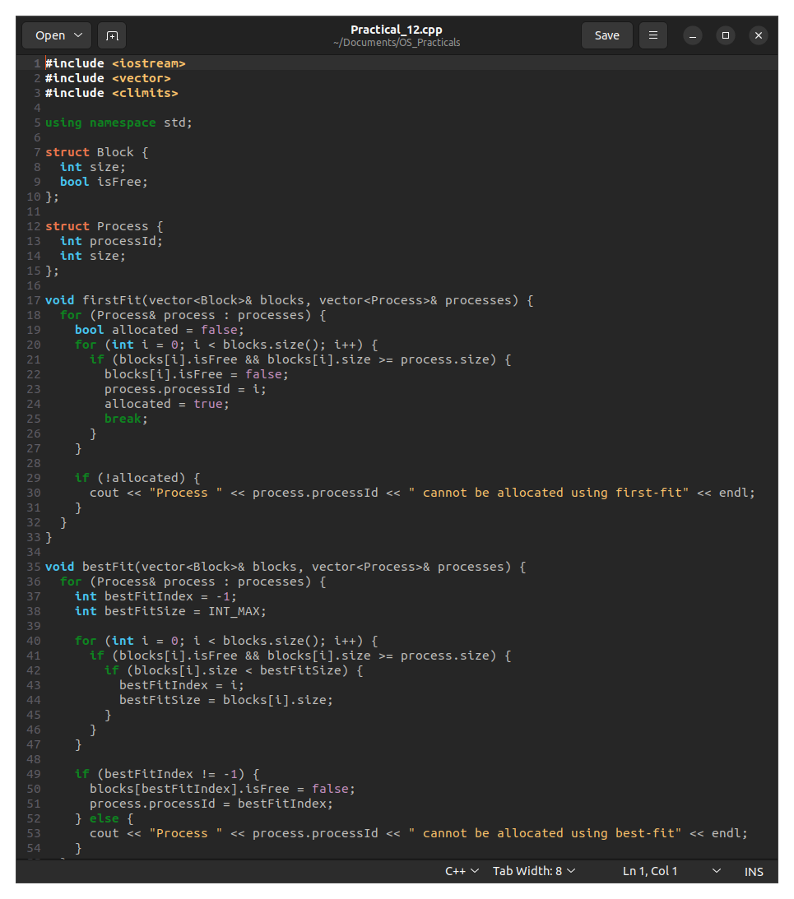

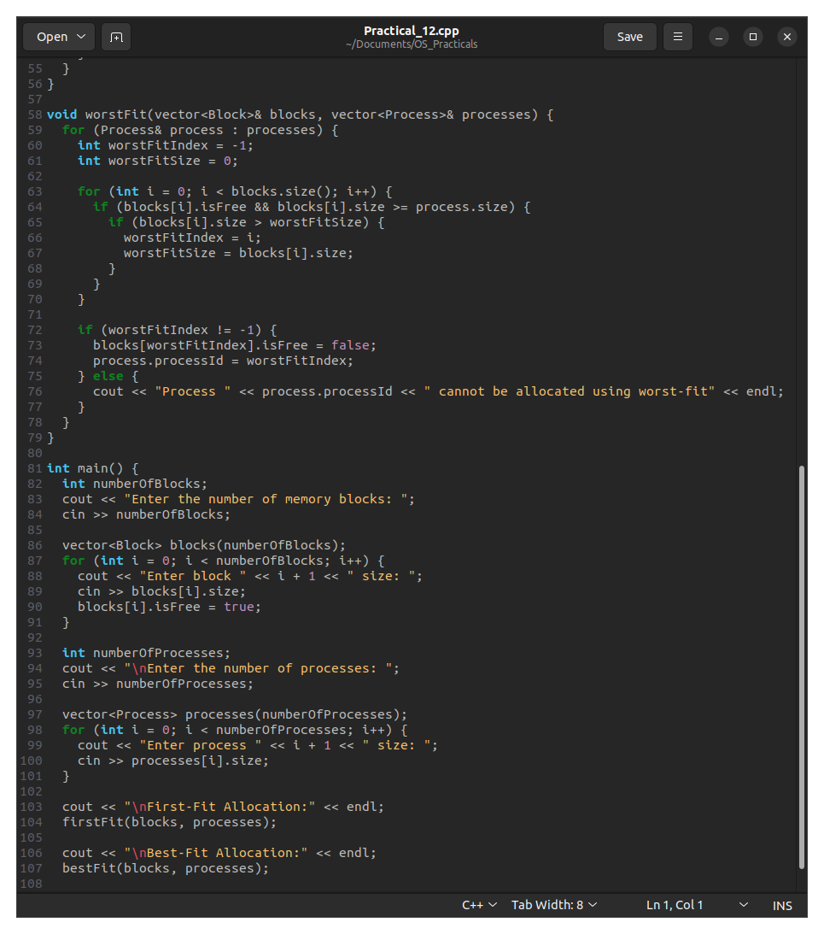



OUTPUT:

